**Contents**

**Background 1**

**Brief History of the Company 1**

**Main Product and Service 2**

**Main products are; 2**

**Domestic Banking 2**

**International Banking 3**

**E-Banking 3**

**Main Customer or End Users 3**

**Economic Ownership Dimension 3**

**Overall Organizational Chart 4**

**In which section of the company you have been working in 5**

**Internal Auditing 5**

**Internal Auditing system in United Bank 6**

**Which work piece or work task you have been executing 7**

**What procedures and methods you have been using while performing your task 9**

**What challenges you have been facing while performing your work tasks 9**

**What measure have you have been taking in order to overcome the challenges 9**

**short summary of the project 9**

**Problem statement 10**

***General objective* 10**

***Specific objective* 10**

**methodology 11**

**Result & Discussion 11**

**Literature review 12**

***Definition of Auditing* 12**

**Internal Auditing 12**

**Gains from my Internship experience 15**

**Conclusion 15**

**References 16**

Background

One of the main objectives of financial institutions is mobilizing resources (in particular domestic saving) and channeling them to the would-be investors. This intermediation role of financial institutions takes different forms in different economic systems. Ethiopia’s history of the last three decades clearly shows the validity of this statement.

Banks play an important function in the economy of any country. They are the main intermediaries between those with excess money (depositors) and those individuals and businesses with viable projects but requiring money for their investment (creditors). Banks have at least the following functions: lending money, depositing others’ money, transferring money locally or globally and working as paying agent.

Private commercial banks are a recent phenomenon in the Ethiopian economy. They came into existence after the downfall of the Dergue regime. After the downfall of the Dergue private commercial banks were allowed to operate and they started to have market share, and now they have some growing market share in the Ethiopian economy and are some of the major players in the Ethiopian economy. Their number is also growing from time to time and currently new commercial banks are joining the market. One of the private shares Bank Companies is United Bank.

# Brief History of the Company

United bank is one of the private banks found in Ethiopia. United Bank was incorporate as a share company on 10 September 1998 in accordance with the commercial code of Ethiopia of 1960 and the licensing and supervision of banking business proclamation no.84/1994. The bank obtained a banking services license from the national bank of Ethiopia and registered with the trade, industry and tourism bureau of the Addis Ababa City Administration at the time of its establishment. Over the years, united bank built itself into a progressive and modern banking institution, endowed with a strong financial structure and strong management, as well as a large and ever- increasing customers and correspondents base. United bank provides a full-fledged commercial banking service in all its branch outlets to customers with its total 145-networked or automated branches.

# Main Product and Service

With our wide spectrum of products and services to choose from, you’re sure to find the investment that best fits your needs. Our Certified Trust & Financial Advisors will lend their expertise to your plans for your future.

**Products**

* Mutual Funds
* Managed Accounts
* Self Directed Accounts
* Custody Accounts
* Stocks
* Bonds
* REITS

**Services**

* Wealth Management
* Trust Administration
* Agency & custody account administration
* Estate Planning
* Executor Services
* Full service 401(k) administration
* Retirement Planning/Income planning
* IRA management and services

**Main products are;**

**Domestic Banking**

Domestic Banking have the following sub classification;

1. Deposits
2. Credit Facilities
3. Local Transfers

**International Banking**

International Banking includes the following;

1. Trade Service
2. Foreign Service
3. Money Transfer
4. Correspondent Banking

**E-Banking**

This includes the following;

1. Internet Banking
2. Mobile Banking
3. Card Banking
4. POS (Point of Sale)

**Interest Free Banking**

# Main Customer or End Users

A) Economic Ownership Dimension

B) Volume and value of transaction

**Economic Ownership Dimension**

The Bank shall have four broad classifications by economic ownership namely: Private, Government, Public, and Associations.

# Overall Organizational Chart

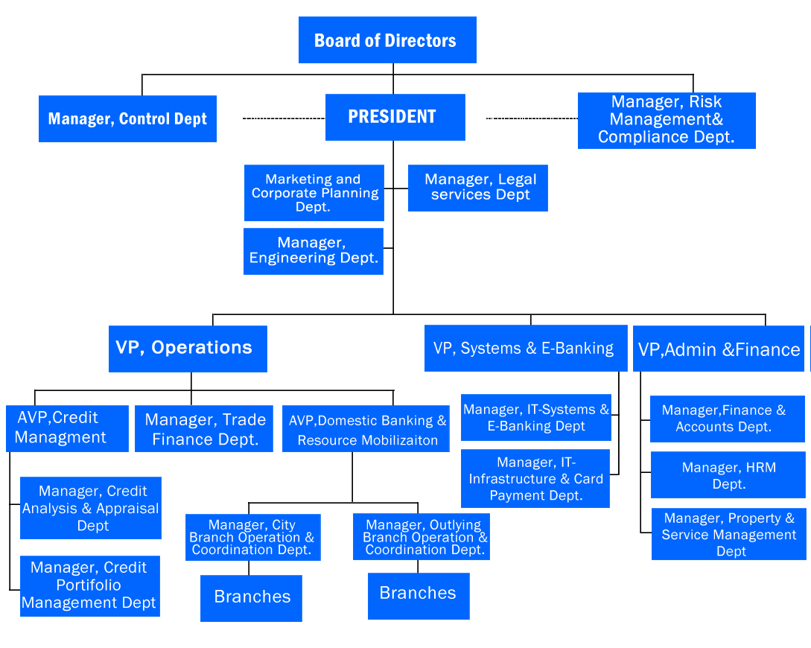

## In which section of the company you have been working in

I worked as an Internal Auditor inside the company.

## Internal Auditing

Internal auditing is a managerial control activity performed with an organization as service to management by an employee of the organization. It reviews operations through the measurement and evaluation of other control mechanisms. Their primary activities are to conduct compliance and operational audits within the organization. However, they assist the external auditor with the annual financial statement audit. Internal auditors could employ by Individuals, companies, partnerships, or government agencies. The Institute of Internal Auditors (IIA) has developed set of standards that should be followed by internal auditors and Established certification program – which Includes passing of uniform writer examination. Like external auditors they must be Independent and objective.

Overall, internal controls also defined as operational checks and balances that prevent loss due to fraud, waste, abuse, and management of resources. The resources include: personnel, information, and capital.

Many researches emphasize the necessity and importance of internal control system in the banking system. An insufficient internal control system often causes an inability to detect fraudulent activities and a decrease in the performance of the bank .

Internal control is a process affected by the board of directors, senior management and all levels of employees. It is not solely a procedure or policy that is performed at a certain point in time, but rather it is continually operating at all levels within the bank. The board of directors and senior management are responsible for establishing the appropriate culture to facilitate an effective internal control process and for monitoring its effectiveness on an ongoing basis; however, each individual within a corporation must participate in the process.

**Internal control system** asserts that the system should be always kept under control and

supervision since people tend to think about their interests more rather than the interests of the

corporation. If there is a failure in the financial accounting system of a corporation, a decrease in assets and an increase in abuses will inevitably takes place in the absence of an effective internal control system

examined the impact of internal control system in banking sector and according to the findings; the lack of an effective internal control system is the major cause of bank frauds in Nigeria. It is then, concluded that the management of every bank should create and establish a standard internal control system, strong enough to stand against the wiles of fraud in order to promote continuity of operations and to ensure the liquidity, solvency and going concern concept of the bank.

the following six essential components of an effective internal control system;

* control environment,
* risk assessment,
* control activities,
* information and communications,
* monitoring, and
* Information technology

# Internal Auditing system in United Bank

United bank is one of private bank in Ethiopia and the bank currently used the system called Flex cube F12.1 version. Which is the most updated program used in the industry. On this ground the internal auditing system is restrained on the system.

Control Department is one of the support units in United Bank. It has two divisions (Internal, System and IT audit and Inspection Divisions), two sections (Internal, System and IT audit and Inspection Sections), Branch Audit and Archive Unit. Both functionally and administratively, Branch Auditors are reporting to Control Department. In particular, Internal, System and IT audit Division is responsible to communicate, follow up and manage branch audit activities.

* All branches’ auditor expected to prepare monthly report.
* The report should cover daily activates of the branch.
* Internal auditor expected surprise cash count at least two times per month
* Check monthly reports of loan, IBD, and operation sections.
* The stocks of cheque pads, CPO, passbooks, drafts, TT’s/ telegraphic transfer/ forms, CDT’s, and any tickets and certificates should checked and reported timely.
* The discrepancies and variations need follow up and rectification on time.
* Annual inventory take over and reporting should checked and signed before sending to head office
* The internal auditor report directly to head office control unit and cc to branch manager.

The above duties shows, the bank’s internal auditors system activities based up on the flex cube formats. The program prepares the monthly reports, daily balances, and trial balances, etc. So the auditors expected to know the system itself beyond the formal activities

## Which work piece or work task you have been executing

as I stated in the above I was involved as an Internal Auditor.

**Duties and responsibilities of internal auditor**

|  |  |  |
| --- | --- | --- |
| Ensure efficiency and accuracy of operational duties   * Safe handling of tickets and documents. * Timely reporting control weaknesses, compliance breaches and operational loss events to the branch manager * Proper handling of customers | * Post-check validity of tickets and daily opened accounts. * Maintain tickets, posting journal and account opening documents under his/her custody   Post checks the particulars of any payment and deposit tickets   * Makes sure that computations, journalizing and posting of daily transactions/entries are in conformity with operational procedures. * Take surprise run-up of tracer and outstanding items * Prepare discrepancy report every fifteen days and report to Branch Manager and Monitoring and Compliance Officer * Dispatch bank statements to account holders * Make surprise checking of cash and non-cash items * Record and follow-up rectification of discrepancy of findings Keeps custody of closed mandate files, closed and replaced passbooks * Examine cash excess and cash shortage * Checks mandate files of account holders periodically * Issues duplicate advise or document upon request of customers * Ensure that documents in record room are safely maintained * Dispatch bank statements to account holders * Complete other related duties as assigned | * Standard processing cost   Standard processing time   * Customer satisfaction |

## What procedures and methods you have been using while performing your task

Internal audit is done by the procedure of the bank.

## What challenges you have been facing while performing your work tasks

* Inter posts
* Lack of ratification discrepancy
* Un authenticate id and tin for current account
* Communication with staff
* Communication with customers

## What measure have you have been taking in order to overcome the challenges

* Trying to do with procedure
* Good communication with staff
* Amend the old procedures
* Update self knowledge

## short summary of the project

This study has discovered a general overview of the components on the currently on going auditing system in the United bank S,C. Although the limitation of sample size and a need for more refined methodology and follow-up surveys with large sample in the whole branches are required. In the meanwhile, the study has identified both the problem and the solution on recommendation is stated. The problem encountered according to the sample collected on the questionnaire and in the comments of the interview. In order to evade this problem further development and achievement in this regard needed.

Generally, based on the study made and its listed findings the following conclusion and recommendation made.

# Problem statement

* Ensure efficiency and accuracy of operational duties
* Safe handling of tickets and documents.
* Timely reporting control weaknesses, compliance breaches and operational loss events to the branch manager Standard processing cost
* Standard processing time
* Customer satisfaction
* Proper handling of customers
* Post-check validity of tickets and daily opened accounts.
* Maintain tickets, posting journal and account opening documents under his/her custody
* Post checks the particulars of any payment and deposit tickets
* Makes sure that computations, journalizing and posting of daily transactions/entries are in conformity with operational procedures.
* Take surprise run-up of tracer and outstanding items
* Prepare discrepancy report every fifteen days and report to Branch Manager and Monitoring and Compliance Officer
* Dispatch bank statements to account holders

## *General objective*

The general objective of this study is to assess the internal auditing system on the performance of united bank, birramba branch.

## *Specific objective*

1. To assess the bank’s system influence the activities of auditors.

2. To answer how Auditors interaction with the bank system in every activity

3. To explain the bank auditor activities related with the bank and the government policies.

4. To assessing the auditor’s contribution on overall performance of the bank.

5. To identify what is limit and the problem of internal auditing system

# methodology

* Research design
* sampling
* Data collection

## Result & Discussion

During the month, the auditor has to cover different operational activities undertaken in the Branch and findings in this regard are included in the body of the report. The following are some of the major audit activities/areas covered during the month;

Customer account opening

* Disbursement of loans
* Permit and Purchase order approval
* Payroll
* Agent Banking
* Interest free banking
* others

In addition, part of the audit activities covered during the month are checking and verifying daily transactions in the system against supporting documents, checking of transactions related to settlement of import and export documents, loans after disbursement and others.

**Surprise Cash Count**

Surprise cash count has been made at least two times per month. The count has been conducted in detail for big notes with denominations of Br. 100 and Br. 50 and on sample for bundles of other denominations. Foreign currency has also been counted in detail. The result of the count is in agreement with the record shown in the system as well as the Cash Book Register or if there is any deviation, the auditor immediately report to the branch manager and cc to head of audit unit at head office.

# Literature review

## *Definition of Auditing*

The American Accounting Association, committee on Basic Auditing concepts - Defined Auditing as:

‘’Auditing is systematic process of objectively obtaining and evaluating evidence regarding assertions about economic actions and events to ascertain the degree of correspondence between assertions and established criteria and communicating the results to interested users.’’

## Internal Auditing

Internal auditing is a managerial control activity performed with an organization as service to management by an employee of the organization. It reviews operations through the measurement and evaluation of other control mechanisms. Their primary activities are to conduct compliance and operational audits within the organization. However, they assist the external auditor with the annual financial statement audit. Internal auditors could employ by Individuals, companies, partnerships, or government agencies. The Institute of Internal Auditors (IIA) has developed set of standards that should be followed by internal auditors and Established certification program – which Includes passing of uniform writer examination. Like external auditors they must be Independent and objective.

Overall, internal controls also defined as operational checks and balances that prevent loss due to fraud, waste, abuse, and management of resources. The resources include: personnel, information, and capital.

Many researches emphasize the necessity and importance of internal control system in the banking system. An insufficient internal control system often causes an inability to detect fraudulent activities and a decrease in the performance of the bank .

Internal control is a process affected by the board of directors, senior management and all levels of employees. It is not solely a procedure or policy that is performed at a certain point in time, but rather it is continually operating at all levels within the bank. The board of directors and senior management are responsible for establishing the appropriate culture to facilitate an effective internal control process and for monitoring its effectiveness on an ongoing basis; however, each individual within a corporation must participate in the process.

Socol (Socol 2011) mentioned that the administration board and executive management

Promotes high standards of ethics and integrity, establish an institutional culture highlighting and demonstrating the importance of internal control on all organizational levels. All employees of the bank must be aware of the role they have in the internal control system and must be actively involved in this process.

**Internal control system** asserts that the system should be always kept under control and

supervision since people tend to think about their interests more rather than the interests of the

corporation. If there is a failure in the financial accounting system of a corporation, a decrease in assets and an increase in abuses will inevitably takes place in the absence of an effective internal control system (Yayla 2006, p. 112).

Olatunji (Olatunji, 2009) examined the impact of internal control system in banking sector and according to the findings; the lack of an effective internal control system is the major cause of bank frauds in Nigeria. It is then, concluded that the management of every bank should create and establish a standard internal control system, strong enough to stand against the wiles of fraud in order to promote continuity of operations and to ensure the liquidity, solvency and going concern concept of the bank.

Amudo and Inanga (Amudo et al. 2009) identify the following six essential components of an effective internal control system;

* control environment,
* risk assessment,
* control activities,
* information and communications,
* monitoring, and
* Information technology

The findings of the study under evaluation results are that measuring effectiveness of internal control is concerned with the existence and functioning of the six major control components identified by the model.

One of the, perhaps the most prominent one, vital components of a bank’s structure in modern banking system is internal control system in developed or developing countries. Because effective and efficient performance of the system indicates that the bank operates as desired. Consequently, investors and other customers in the market will prefer to use the services of that bank since they will have confidence and peace of mind about bank’s financial stability (Yavuz, 2002).

# Gains from my Internship experience

* Audit is the very hard work and learn that every single word, number, procedure have the very meaningful theoretical, practical and procedural risk.
* I have learned the information in the organization.
* Respect the work time
* Office and personal clean
* I disregarded the agency's property for personal benefit, but I was able to understand that any employee of the organization was required to comply with the rules and regulations according to the requirements and other issues.
* I have learned important team skills like learning experiences from others and sharing ideas, properly communicating with the staff etc….

# Conclusion

* One of the factors for auditors’ performance is the state of working independently from any party. On the finding of the research, more than half of respondent are believed that the auditors are perform their duty free from any parties influence. Even if 10% of them doesn’t agree with the idea. We could conclude that the auditors are independent from branch managers and by the procedure; they are accountable for head office department.
* Among the respondents 60% respondents believed that the duty of the auditors has contribution on the overall performance of the bank. The banks performance is the result of aggregated activities of the staffs and auditors has their own contribution.
* The bank’s system currently in use named flex cube version 12 believed that it minimizes the amount of errors made by the staffs. It shows that the new version is well designed to avoid or to minimize human errors, even if still the system does not make 100% sure of it. On the other hand, it eases auditor’s task, because the system by itself has a nature of balancing and checking module in makers and authorizers stage.

# References

* From company profile and the staff
* [www.unitedbank.com.et/index.php/united-bank-s-history](http://www.unitedbank.com.et/index.php/united-bank-s-history)
* www.businessdictionary.com/definition/auditor.html